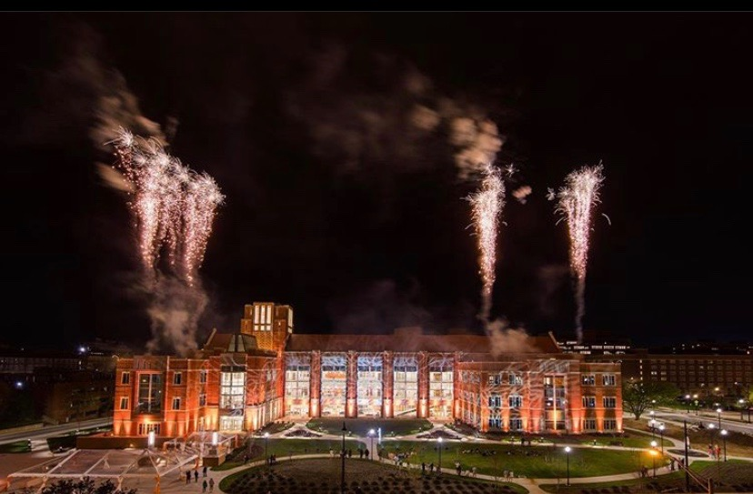

HAPPY 2020. An end to another semester at UT and a start to a new decade… DECADE.

I can’t wrap my head around that. I’ll keep it short and sweet because, you know, we’re on break and no one wants to READ if we don’t have to. However, I was talking to a friend of mine this morning I realized how much this decade will hold. Graduating college, getting a job, moving out of our parents’ house, potentially getting married, going to graduate schools, etc. As I began spiraling into the perceived pressures and nebulous tasks of this coming decade, I said to my friend “wow our fun years are over,” and she said, “no, the next decade is going to be our fun years, too, just a different kind of fun.” She’s right. As graduating seniors, let’s step into the new year and new decade with the mindset that our fun years are not behind us. Our new phase of life and the decade of change we are looking straight in the eyes will be a time of excitement, challenge, and fulfillment. We can look back at our past ten years and see that we’ve graduated from both high school and college, made it through countless lectures, exams, papers, and finals weeks, tried things we never thought we could do, and succeeded, and so much more. We did it. While we will wake up sometime in May without our next step completely laid out for us like it has for the past 16 years of our lives, we will know that we’re capable of tackling this next stage of life.

So, cheers to new life stages, a new decade, and a new year! Let it be your best one yet!

